Contents

Java static nested class 3

# Inner Classes

Inner class means one class which is a member of another class. There are basically four types of inner classes in java.

1) Nested Inner class  
2) Method Local inner classes  
3) Anonymous inner classes  
4) Static nested classes

## Nested Inner class

can access any private instance variable of outer class. Like any other instance variable, we can have access modifier private, protected, public and default modifier.  
Like class, interface can also be nested and can have access specifiers.

Unlike a "regular" class, an inner class can be private or protected. If you don't want outside objects to access the inner class, declare the class as private

class Outer {

   // Simple nested inner class

   class Inner {

      public void show() {

           System.out.println("In a nested class method");

      }

   }

}

class Main {

   public static void main(String[] args) {

       Outer.Inner in = new Outer().new Inner();

       in.show();

   }

}

As a side note, we can’t have static method in a nested inner class because an inner class is implicitly associated with an object of its outer class so it cannot define any static method for itself. For example the following program doesn’t compile

class Outer {

   void outerMethod() {

      System.out.println("inside outerMethod");

   }

   class Inner {

      public static void main(String[] args){

         System.out.println("inside inner class Method");

      }

   }

}

An interface can also be nested and nested interfaces have some interesting properties

Method Local inner classes  
Inner class can be declared within a method of an outer class. In the following example, Inner is an inner class in outerMethod().

|  |
| --- |
| class Outer {      void outerMethod() {          System.out.println("inside outerMethod");          // Inner class is local to outerMethod()          class Inner {              void innerMethod() {                  System.out.println("inside innerMethod");              }          }          Inner y = new Inner();          y.innerMethod();      }  }  class MethodDemo {      public static void main(String[] args) {          Outer x = new Outer();          x.outerMethod();      }  } |

Method Local inner classes can’t use local variable of outer method until that local variable is not declared as final. For example, the following code generates compiler error (Note that x is not final in outerMethod() and innerMethod() tries to access it)

|  |
| --- |
| class Outer {     void outerMethod() {        int x = 98;        System.out.println("inside outerMethod");        class Inner {           void innerMethod() {              System.out.println("x= "+x);           }        }        Inner y = new Inner();        y.innerMethod();     }  }  class MethodLocalVariableDemo {     public static void main(String[] args) {        Outer x=new Outer();        x.outerMethod();     }  } |

Output:

local variable x is accessed from within inner class;

needs to be declared final

**Note :**Local inner class cannot access non-final local variable till JDK 1.7. Since JDK 1.8, it is possible to access the non-final local variable in method local inner class

The main reason we need to declare a local variable as a final is that local variable lives on stack till method is on the stack but there might be a case the object of inner class still lives on the heap.  
Method local inner class can’t be marked as private, protected, static and transient but can be marked as abstract and final, but not both at the same time.

## Java static nested class

A static class i.e. created inside a class is called static nested class in java. It cannot access non-static data members and methods. It can be accessed by outer class name.

* It can access static data members of outer class including private.
* Static nested class cannot access non-static (instance) data member or method.

|  |
| --- |
| class Outer {     private static void outerMethod() {       System.out.println("inside outerMethod");     }       // A static inner class     static class Inner {       public static void main(String[] args) {          System.out.println("inside inner class Method");          outerMethod();       }     }    } |

Anonymous inner classes  
A class that have no name is known as anonymous inner class in java. It should be used if you have to override method of class or interface. Java Anonymous inner class can be created by two ways:

1. Class (may be abstract or concrete).
2. Interface

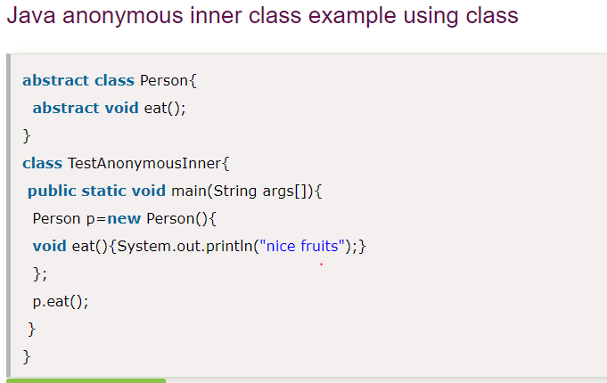

1. A class is created but its name is decided by the compiler which extends the Person class and provides the implementation of the eat() method.
2. An object of Anonymous class is created that is referred by p reference variable of Person type.

